Workflow:

Select the period of data wanted -> take the average of the data per 6 min -> conduct wavelet analysis on the data

Methods tried:

1. MATLAB cwt function with period set:

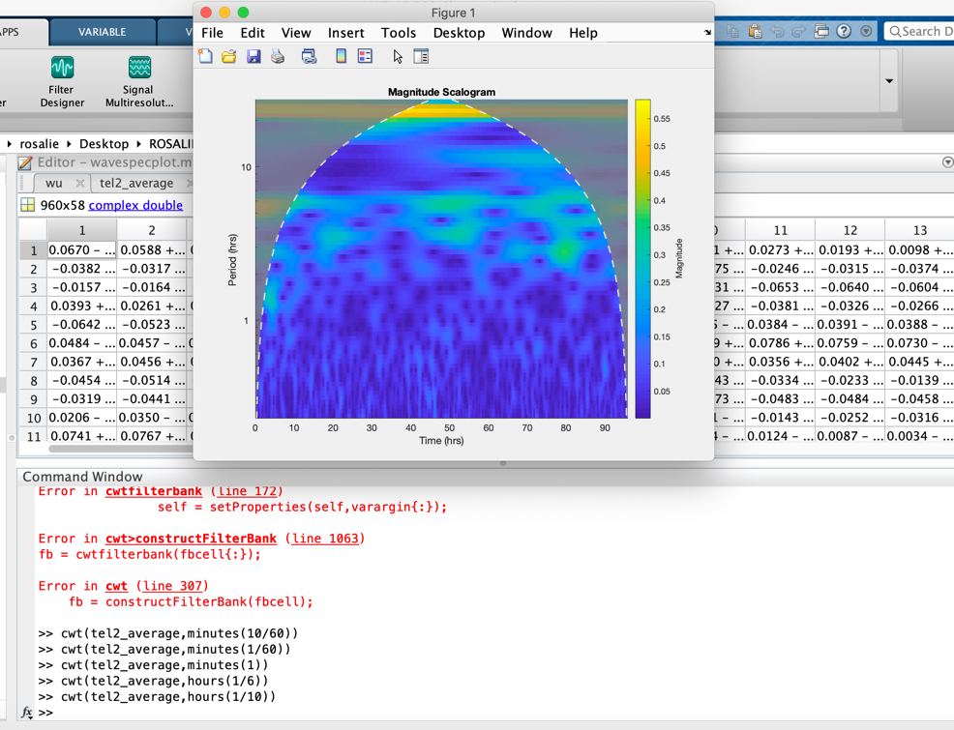

Pro:

* Used Morse wavelet
* Easy to run & visualize

Problem:

* period/ frequency of the function is not set correctly and don’t know how to fix
* the wavelet analysis used in

1. JLab:

Pro:

* Step by step function using Morse wavelet
* Easy to set parameters like period, frequency, gamma and beta

Problem:

* Too make steps (my understanding of what happened: first construct morse wavelet using input parameter gamma and beta, then put the data into wavelet and visualize)
* Can’t find the right function to visualize, the dimension of the matrix always seems to be incorrect, Ben’s paper seemed to use their script